**MS PROJECT**

## C-Fresh

**Team Members:**

Aarnav Gauli

Sweing Nakarmi

Abhishek Sharma

Atul Bhattarai

Saugat Rajbhandari

Yunisha Neupane

Sushant Gautam

Calendar

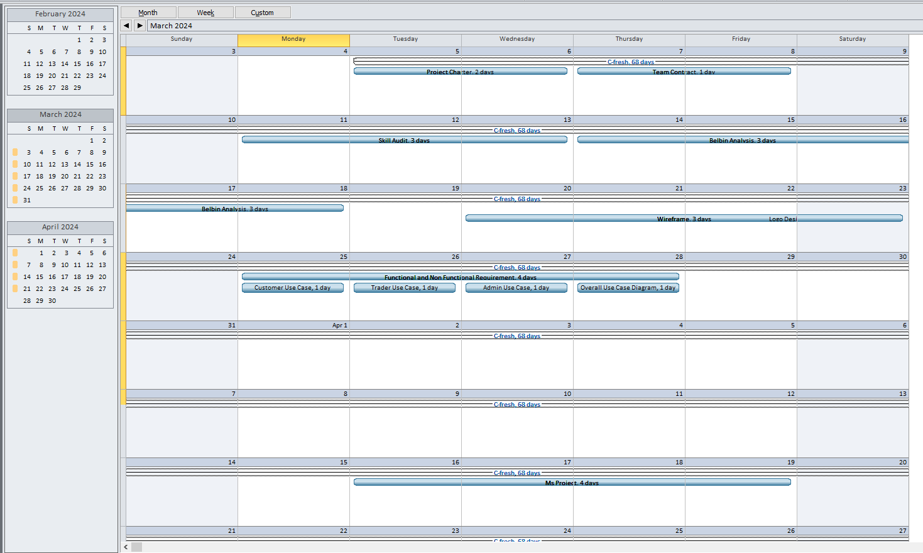

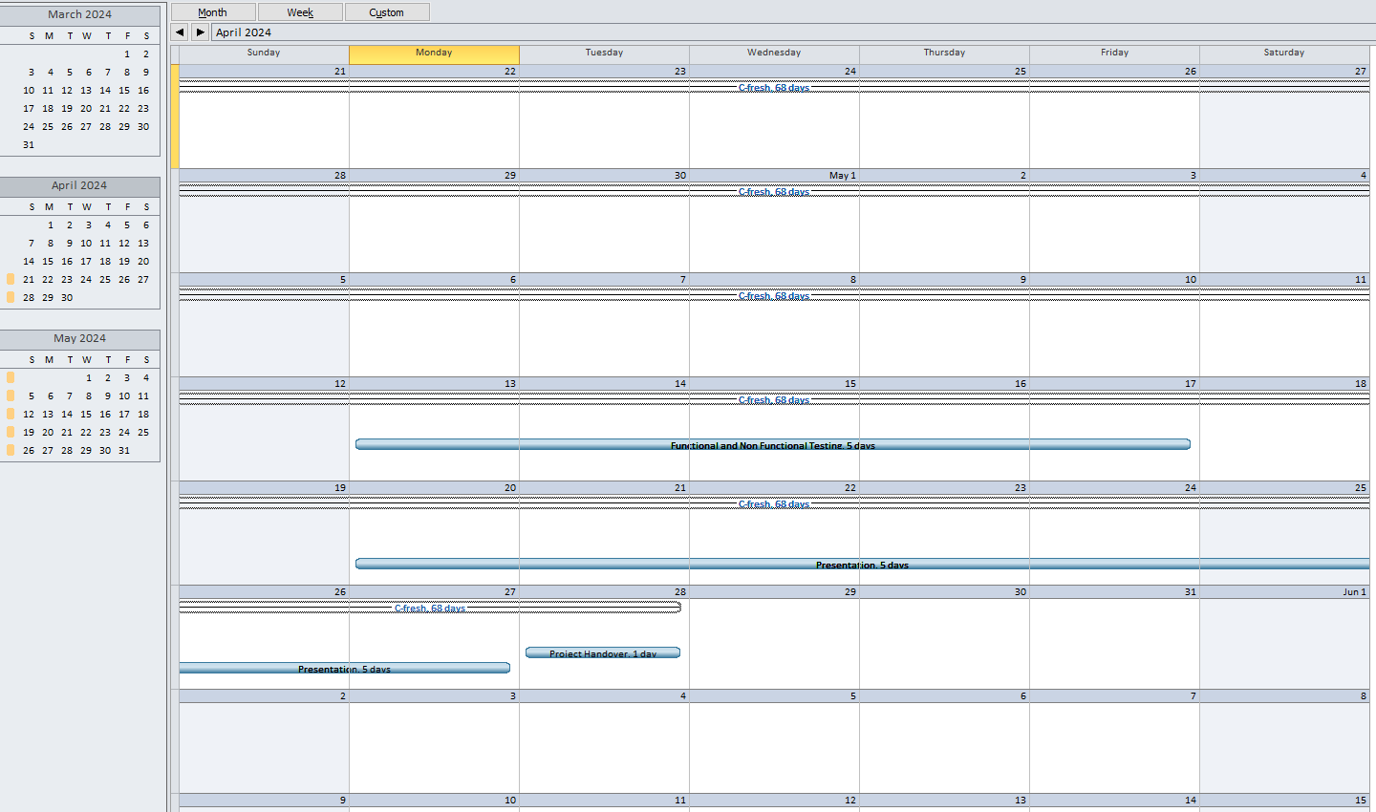

Gantt Chart

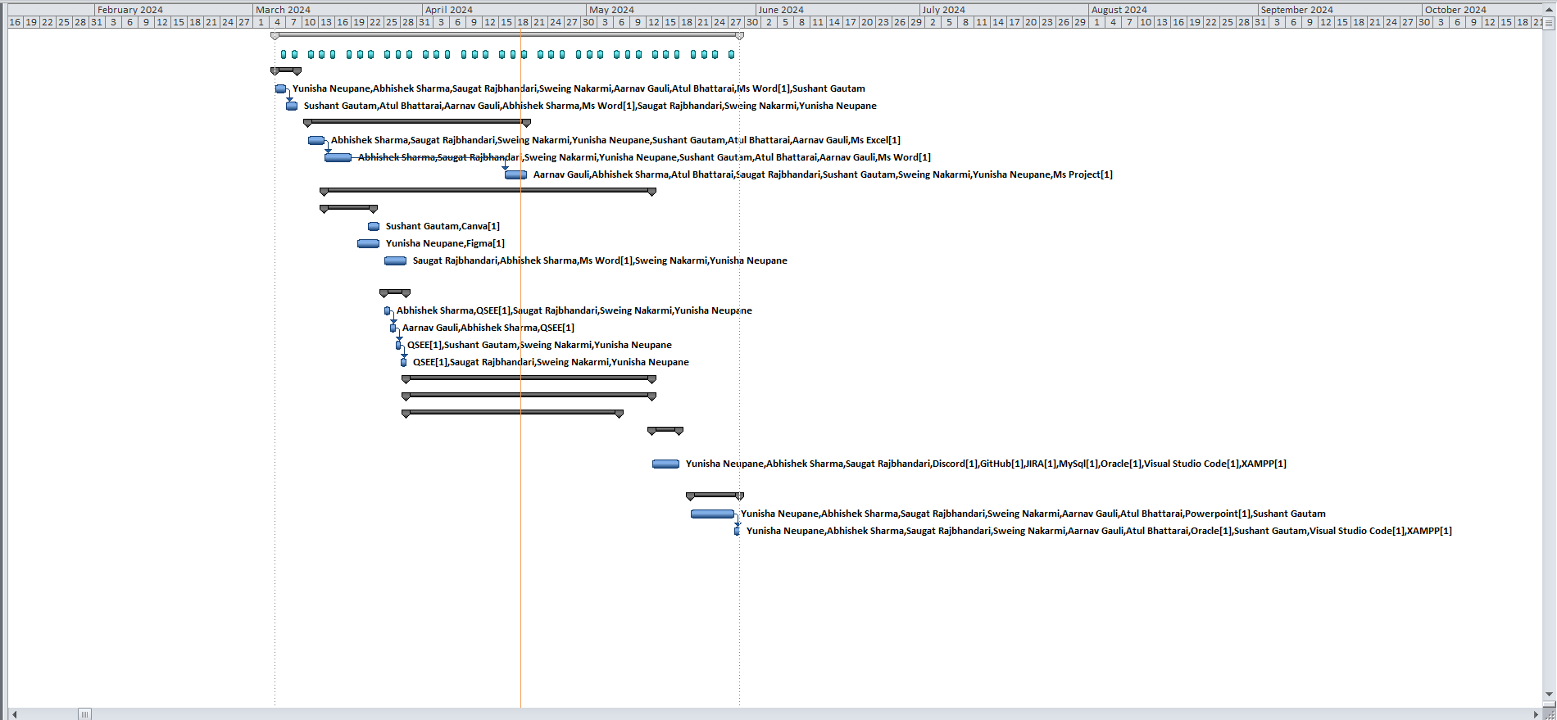

Task Sheet

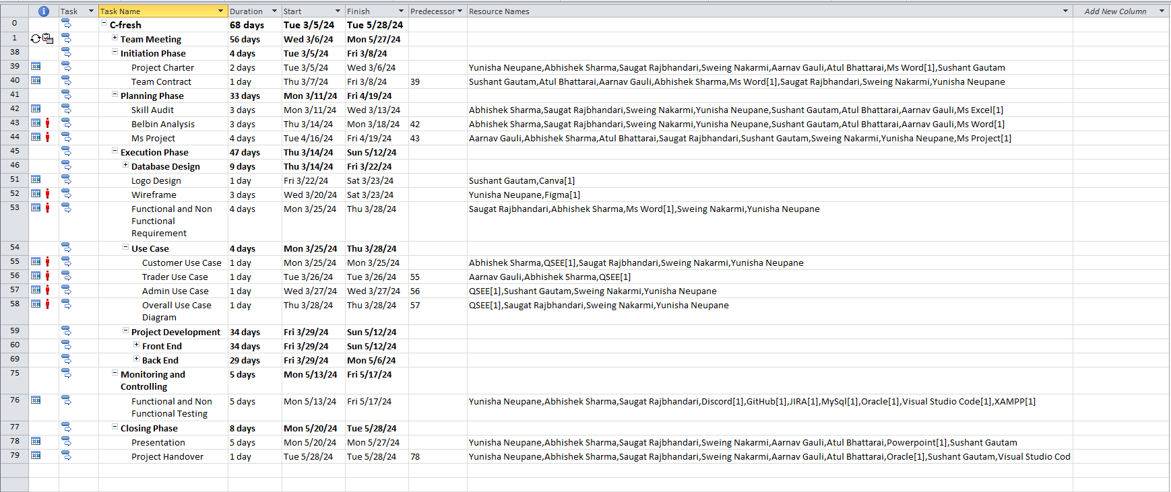

Time Line

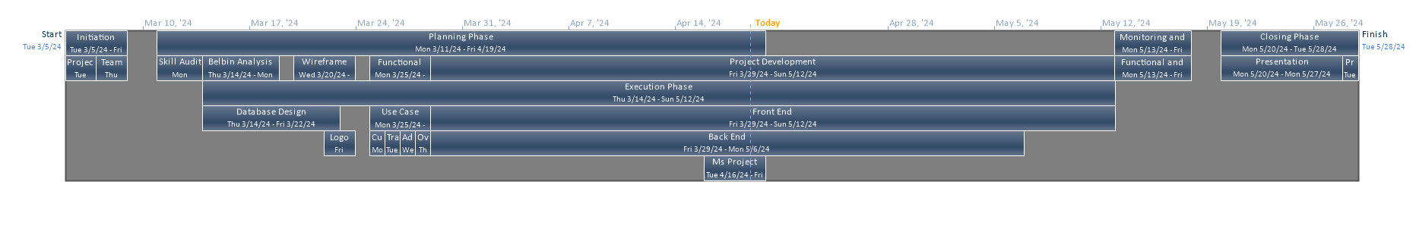

Resource Sheet

